**Ideation Phase**

**LearnHub:Your Center For Skill Enhancement**

|  |  |
| --- | --- |
| Date | 27 June 2025 |
| Team ID | LTVIP2025TMID43500 |
| Project Name | LearnHub:Your Center For Skill Enhancement |
| Maximum Marks | 4 Marks |

**LearnHub:Your Center For Skill Enhancement:**

LearnHub is a dynamic and comprehensive platform designed to empower individuals by enhancing their skills across a wide range of disciplines. Whether you're a student, a working professional, or someone looking to upskill or reskill, LearnHub serves as a centralized hub for learning, growth, and personal development.

**Key Features:**

1. **Skill-Based Learning:**  
   LearnHub focuses on practical, in-demand skills relevant to today’s job market. From coding, digital marketing, and design to communication, leadership, and time management - the platform offers curated learning paths that match individual career goals.
2. **Centralized Resource Hub:**  
   All resources — courses, tutorials, articles, and workshops — are organized in one easy-to-navigate place, making it simple for learners to find what they need.
3. **Flexible Learning Options:**  
   LearnHub supports self-paced modules, live instructor-led sessions, and hands-on projects to cater to different learning styles and schedules.
4. **Skill Tracking and Assessment:**  
   Users can track their progress, take quizzes and assessments, and receive certifications upon completion. This helps them stay motivated and showcase their achievements.
5. **Community and Mentorship:**  
   A built-in community feature connects learners with peers, mentors, and industry experts for collaboration, networking, and guidance.

**Tech Stack Used:**

* Frontend: HTML, CSS, JavaScript
* Backend: Node.js, Express.js
* Database: MongoDB
* Tools & Platforms: Git, GitHub, VS Code

**Architecture :**

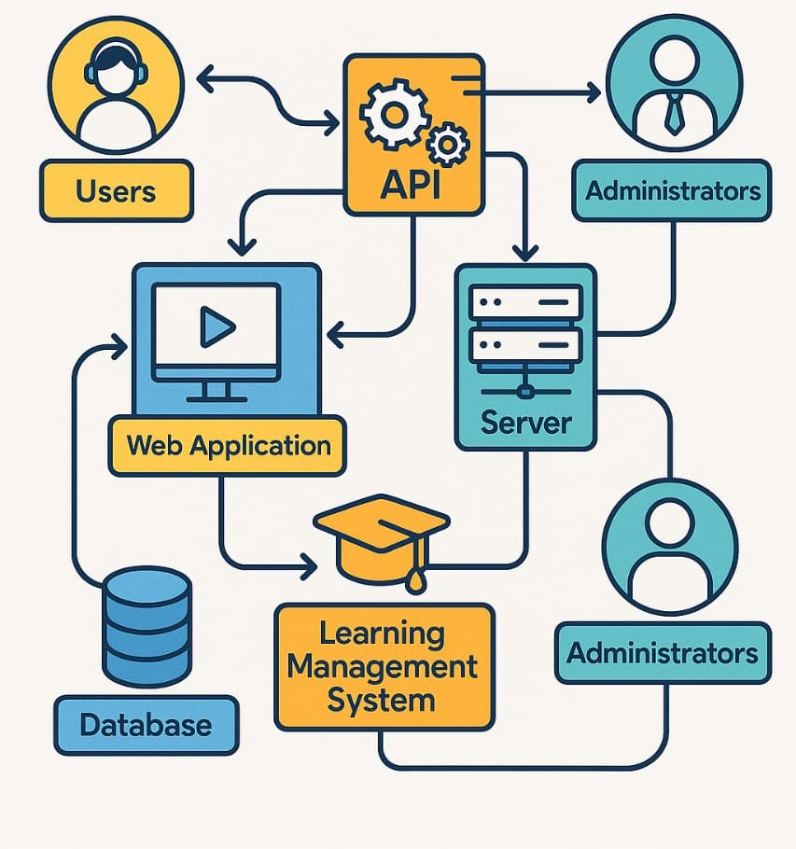

**Conclusion:**

LearnHub is a helpful platform where anyone can improve their skills and grow in their career. With easy-to-use resources, flexible learning, and support from others, it makes learning simple and effective. In today’s world, learning new skills is important — and LearnHub is the perfect place to start.